**System Design Document:**

RF Direction of Arrival System

Ryan Clayton

Robert Kramer

Dalton Mitchum

Krishna Patel

Sylvie Sorese

|  |  |
| --- | --- |
| Version | Date |
| V1.0 | 2/18/2021 |
| V2.0 | 3/18/2021 |
| V3.0 |  |

Table of Contents

1 INTRODUCTION **3**

1.1 Purpose and Scope 3

1.2 Project Executive Summary 3

1.2.1 System Overview 3

1.2.2 Design Constraints 3

1.2.3 Future Contingencies 4

1.3 Document Organization 4

1.4 Project References 4

1.5 Glossary 4

2 SYSTEM ARCHITECTURE **5**

2.1 System Hardware Architecture 5

2.2 System Software Architecture 7

2.3 Internal Communications Architecture 7

3 HUMAN-MACHINE INTERFACE **8**

3.1 Inputs 8

3.2 Outputs 8

4 DETAILED DESIGN **9**

4.1 Signal of Interest 9

4.2 Hardware Detailed Design 9

4.3 Software Detailed Design 13

4.3.1 Demodulation Subsystem 13

4.3.2 GPIO Subsystem 13

4.3.3 Triangulation Subsystem 13

4.4 Internal Communications Detailed Design 14

5 EXTERNAL INTERFACES **14**

5.1 Interface Architecture 14

5.2 Interface Detailed Design 14

6 SYSTEM INTEGRITY CONTROLS **14**

# 1 INTRODUCTION

## 1.1 Purpose and Scope

The purpose of the System Design Document is to describe the system requirements, system architecture, human-machine interfaces, detailed design, and external interfaces for RF Direction of Arrival System .

## 1.2 Project Executive Summary

This section provides a descriptive overview of the DoA system from a management perspective.

### **1.2.1 System Overview**

The goal of the Radio Frequency (RF) Direction of Arrival System is to design an affordable system that detects the directions of arrival of an RF propagating wave, in the ISM band, with the intention of eventually being used in a classroom setting. There are three main sections to the system. This consists of the antenna array, the GNU radio/SDR receiver and the Raspberry Pi. The antenna array detects the signal which is then sent through the switching array. Then the signal is passed through a bandpass filter and amplifier before it is sent to the HackRF One. The Raspberry Pi will then receive the signal from the HackRF One to be processed. Once the signal is processed, the result will be displayed on the display screen (GNURadio).

FIGURE 1: Block Diagram of System Overview

### **1.2.2 Design Constraints**

The project is limited to two major factors, budget and components. The total cost of components shall not exceed $1,500. For the project, the components will be purchased from online vendors if possible. The goal is to avoid constructing components as much as possible so that the project can be recreated by someone else.

### **1.2.3 Future Contingencies**

There will be no contingencies applied to this system in the future.

## 1.3 Document Organization

The System Design Document is constructed to provide an overall concept of the system design. This document will explain the hardware and software system architecture. Following that there will be a Human-Machine Interface section where the inputs and outputs will be discussed. The Detailed Design section will go into further details of the hardware and software design aspects of the system. The document will close off with a brief section discussing the integrity controls of the system.

## 1.4 Project References

The references used in the creation and formation of the subsystem:

## 1.5 Glossary

**ADS –** Advanced Design System

**AP-S** – Antennas and Propagation Society

**CT** – Continuous Time

**DoA** – Direction of Arrival

**ERAU** – Embry Riddle Aeronautical University

**GPIO** - General Purpose Input/Output

**IEEE** – Institute of Electrical and Electronics Engineers

**ISM** – Industrial, Scientific, and Medical

**LNA** – Low-Noise Amplifier

**RF** – Radio Frequency

**SDR** – Software Defined Radio

**SPDT** – Single Pole Double Throw

**SP4T** – Single Pole Four Throw

# 2 SYSTEM ARCHITECTURE

This section provides an overview of the hardware and software architecture.

## 2.1 System Hardware Architecture

The DoA detection system consists of multiple hardware components. This section will go in-depth about what each subsystem will do.

The following components will be utilized to connect the system as a whole:

* APAMBJ-135 Antenna - 8 antennas arranged in an octagon shape to build the overall antenna.
* SKY13351-278LF RF Switch – SPDT switch used to send the signal to the SDR.
* PE4244A-Z RF Switch – SP4T switch used to send signal to SPDT switch.
* HackRF One – SDR that receives the 5.8GHz signal.
* HMC311LP3ETR RF Amplifier – Amplifier used to amplify the desired signal after filtering.
* RFBPF1608060K98Q1C RF Band Pass Filter – Filter used to limit bandwidth of output signal to limit interference.
* Raspberry Pi 4– Computer used to determine the direction of signal using frequency modulation.
* PIM370 Display – Extension of RaspberryPi that will display the direction result of DoA system.

Figure 2 demonstrates the design of the 8 antennas that make up the whole antenna system. The antennas will be mounted onto a copper plate with copper deflectors to assist in refining the signal to be detected by one antenna. Figure 3 exhibits the physical design of the antenna array.

Figure. 2 – Basic Antenna Array and Positioning

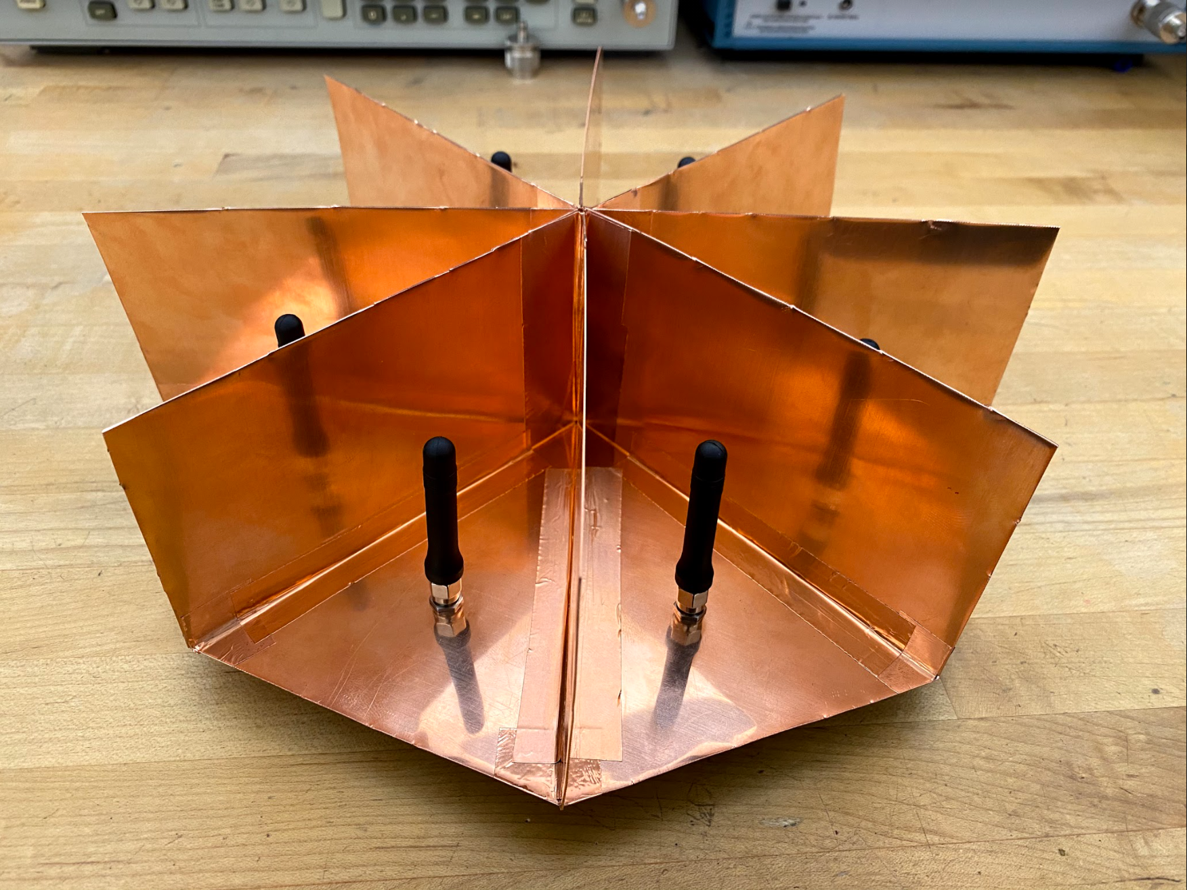

Figure 3 – Antenna Array mounted on copper base.

## 

## 2.2 System Software Architecture

**2.2.1 Raspberry Pi**

The Raspberry Pi will utilize Python to control which antennas are going to be on with use of GPIO pins.

(INSERT diagram here)

Figure 4 - Class Diagram

**2.2.2 GNU Radio**

The GNU Radio will utilize Python to generate a display of the frequencies received by the SDR. This will also output a readable CSV file to interpret the information. Figure 5 below explains the information being read and processed by Python in a block format.

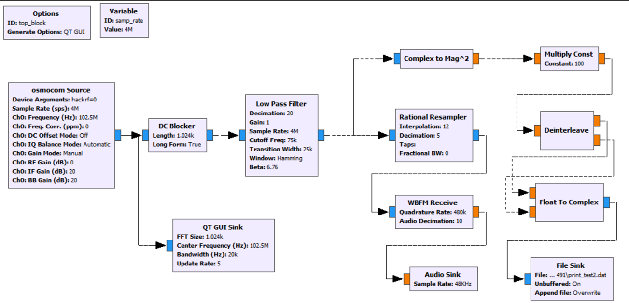

Figure 5 - Block diagram of processed signals

## 2.3 Internal Communications Architecture

The data flow diagram below represents the internal communications of the system. This consists of the directional antenna, the GNU radio/SDR receivers and the Raspberry Pi 4. The antenna array will receive signals. The Raspberry Pi 4 will be used to control which antennas are going to be enabled at certain times. The SDR is to recognize the signals transmitted to the directional antenna and be able to display the reading on GNU radio.

Figure 6 - Data flow diagram of the process of the RF Direction of Arrival System

# 3 HUMAN-MACHINE INTERFACE

## 3.1 Inputs

The only inputs that the user will have to provide to the system are turning the system on or off. There will be a switch that allows the user to do so.

## 3.2 Outputs

The only output of the system will be the direction that the generated 5.8GHz signal is coming from on the display.

Figure 7- Display Output from system. 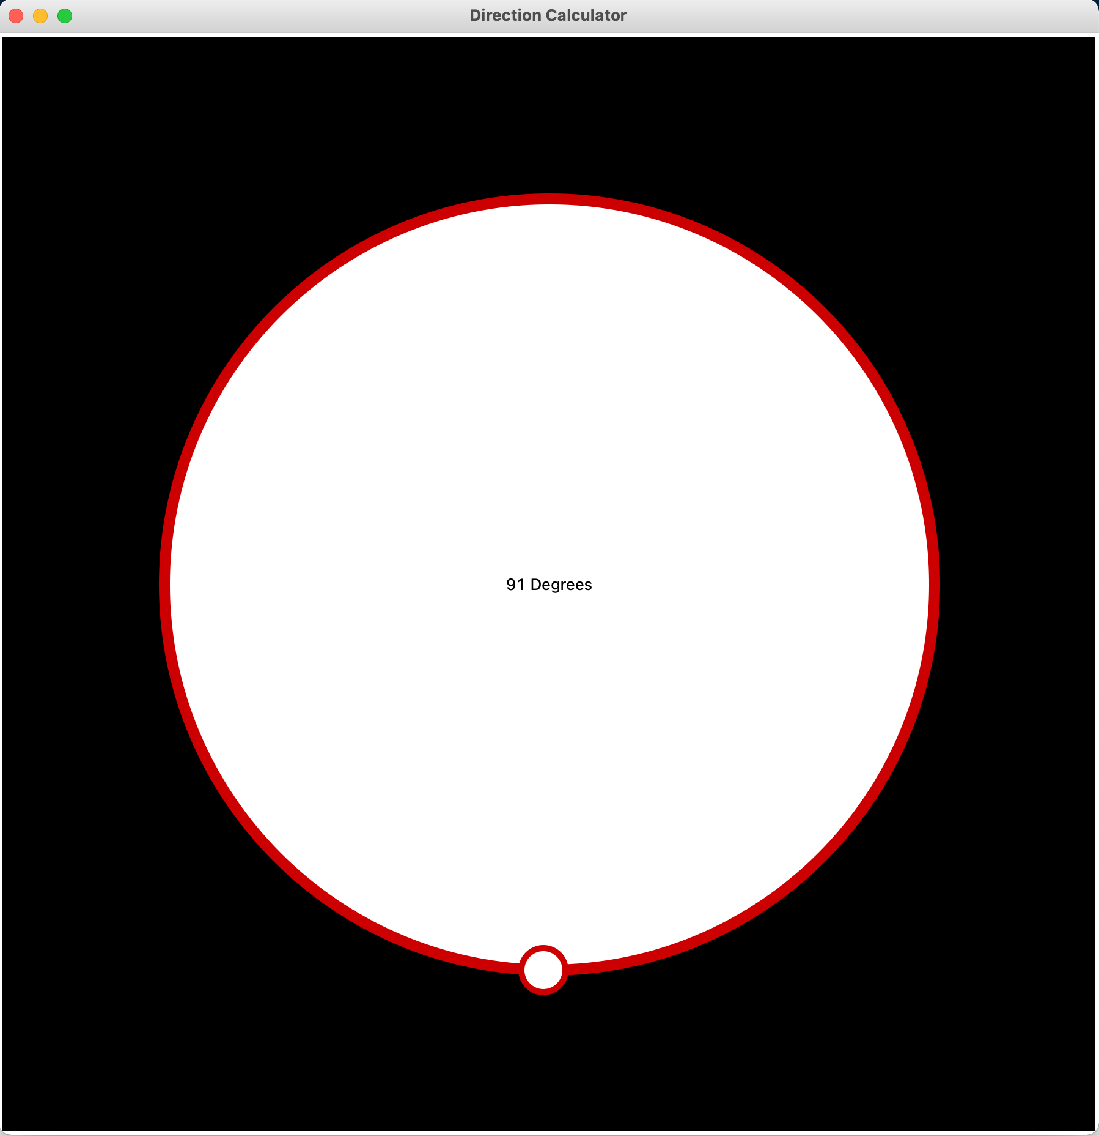

**3.2.1 GNU Radio**

While the system is running, the user will be presented with the radio frequencies that the antenna array can identify. The user will be able to see the frequency range, bandwidth along with being able to listen to the audio when applicable. The QT GUI interface will let the user offset the frequency, isolate the bandwidth, and also filter the sound like in the case of FM radios. This program will also print out the information collected into a readable csv file.

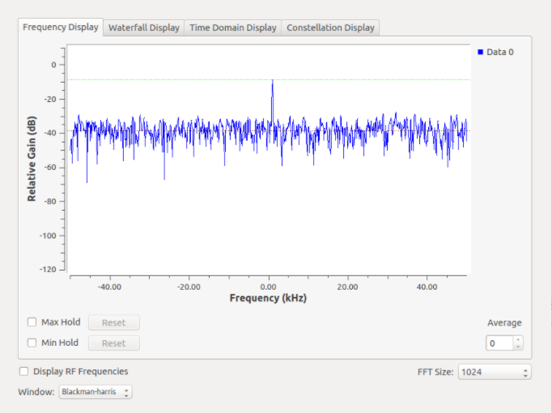

Figure 8 - GNU Radio frequency display

# 4 DETAILED DESIGN

This section contains the detailed designs for the signal of interest, hardware components, and software components of the system.

## 4.1 Signal of Interest

The signal of interest for this project is in the ISM band range. This range is between 5.7-5.9 GHz. The signal will be generated in a lab environment using a signal generator.

## 4.2 Hardware Detailed Design

The system design of the hardware components consists of the antenna array, PCB for switching, external power, and the HackRF One. The specific components used are as follows, eight Abracon APAMBJ-135 antennas, Skyworks SKY13351-378LF SPDT switch, two Peregrine PE42442 SP4T switches, a Raspberry Pi, a Walsin Technology Corporation Band Pass Filter, Analog Devices RF Amplifier, and a HackRF One SDR.

**4.2.1 Antenna Array**

The antennas will be mounted on a copper base with copper deflectors attached to corner off each antenna as previously seen in Figure 3. Each antenna is connected to the two SP4T switches on the PCB board using coaxial cables. From the SP4T switches, the logic control pins connect to the Raspberry Pi. The SP4T switches also connect to the one SPDT switch on the PCB board through coaxial cables. Figures 8 and 9 display the basic design of the switches on each PCB board.

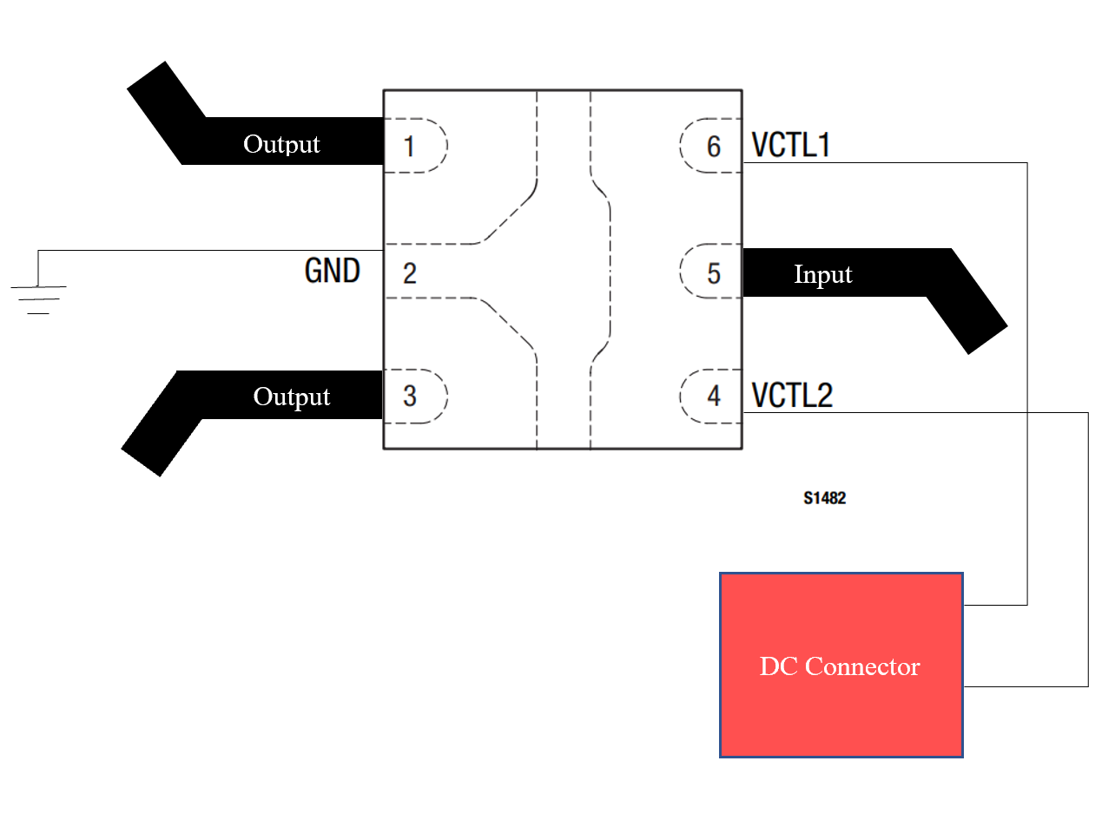

Figure 9 – SPDT switch PCB design.

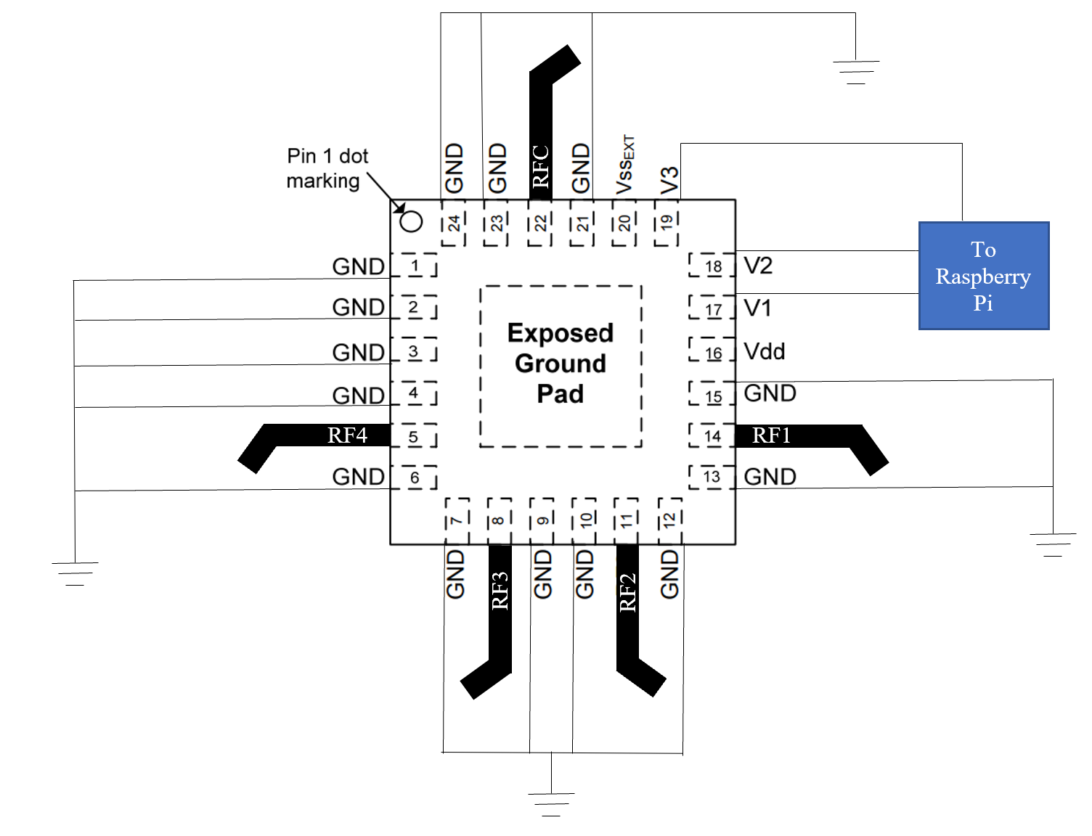

Figure 10 – SP4T switch PCB design.

Before developing the physical PCB boards for the switching array, the design was implemented using the ADS software. Simulations were performed to identify the S-Parameters of the PCB layout and their behavior. The center frequency used for these simulations will be 5GHz. Figure 10 displays the ADS schematic of the SPDT switch. Transmission lines are used to send the signal through the SP4T to the SPDT. Figure 11 displays the ADS schematic for the SP4T switches. In this figure, there is only one SP4T switch. The second SP4T switch will mirror the design of the one displayed in the figure. Transmission lines are used to connect the two SP4T switches to the antenna array and the SPDT switch.

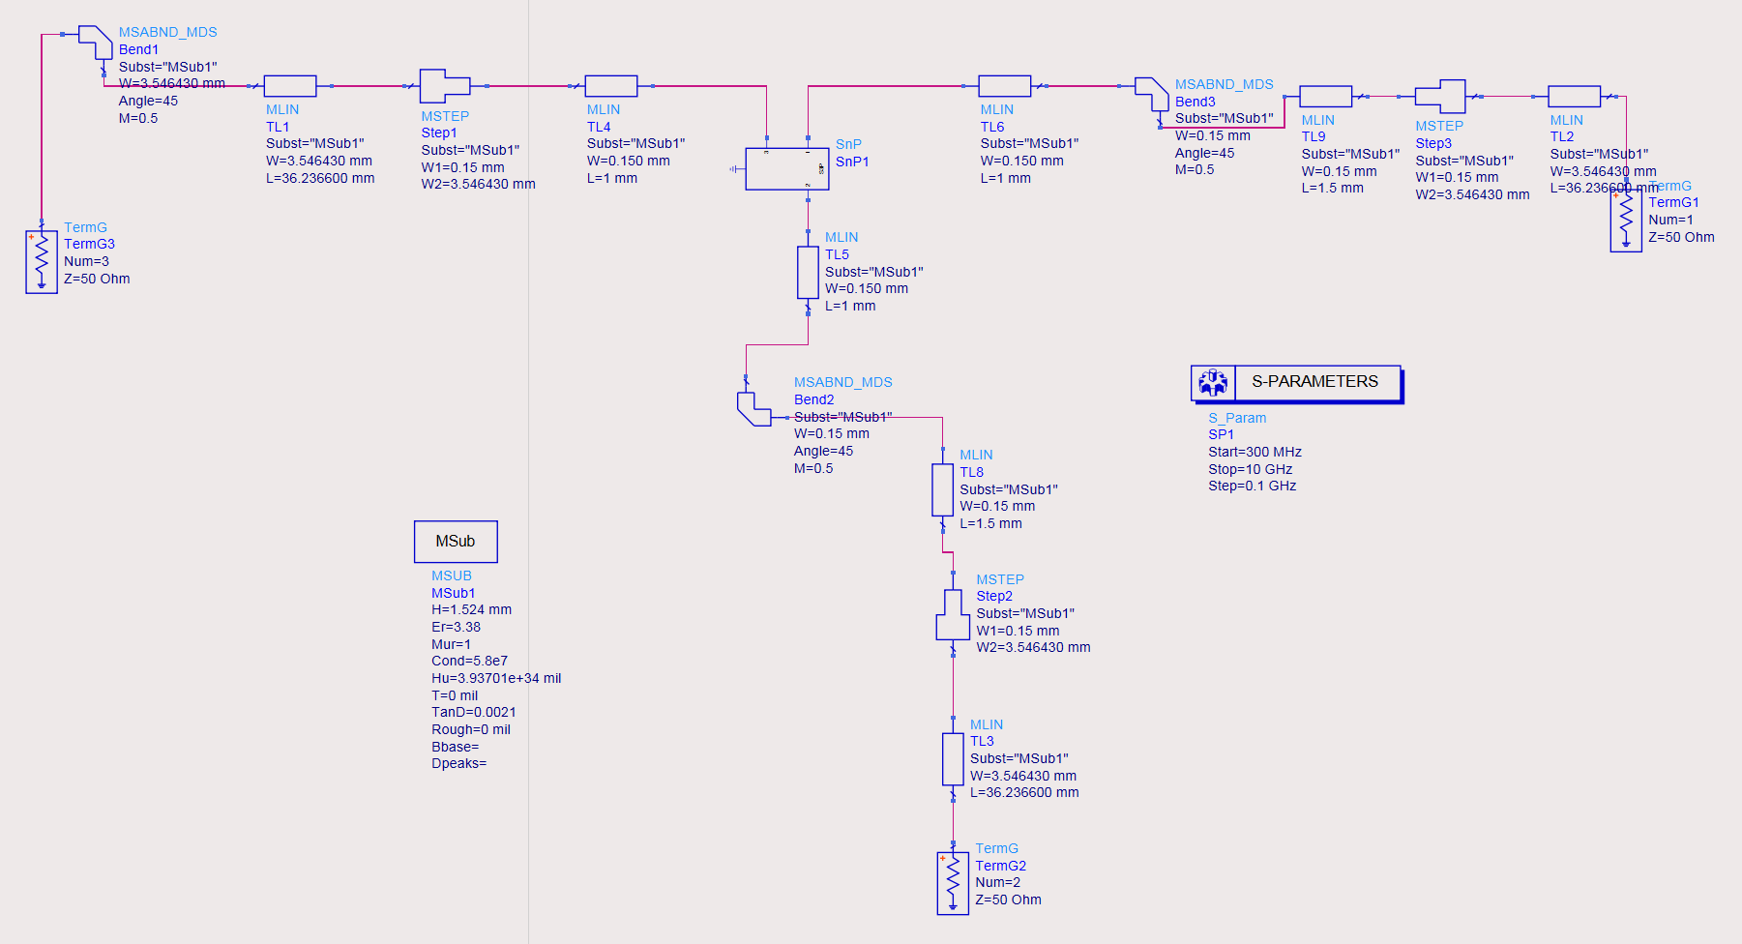

Figure 11 – ADS schematic for SPDT switch.

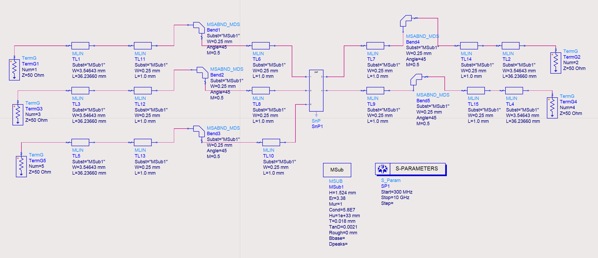

Figure 12 – ADS schematic for the two SP4T switches.

**4.2.2 Raspberry Pi**

The Raspberry Pi will be connected to the SPDT switch to the logic control pins.

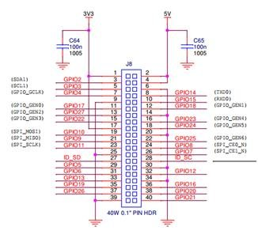

Figure 13 - Schematics of the GPIO pins on the Raspberry Pi 3

**4.2.3 HackRF One**

The HackRF One is a Software Defined Radio that is used as a USP peripheral. It is composed of SMA female antenna connector, Hi-Speed USB 2.0 and half duplex transceiver.

## 4.3 Software Detailed Design

### 4.3.1 Demodulation Subsystem

### 4.3.2 GPIO Subsystem

### 4.3.3 Triangulation Subsystem

### 

## 4.4 Internal Communications Detailed Design

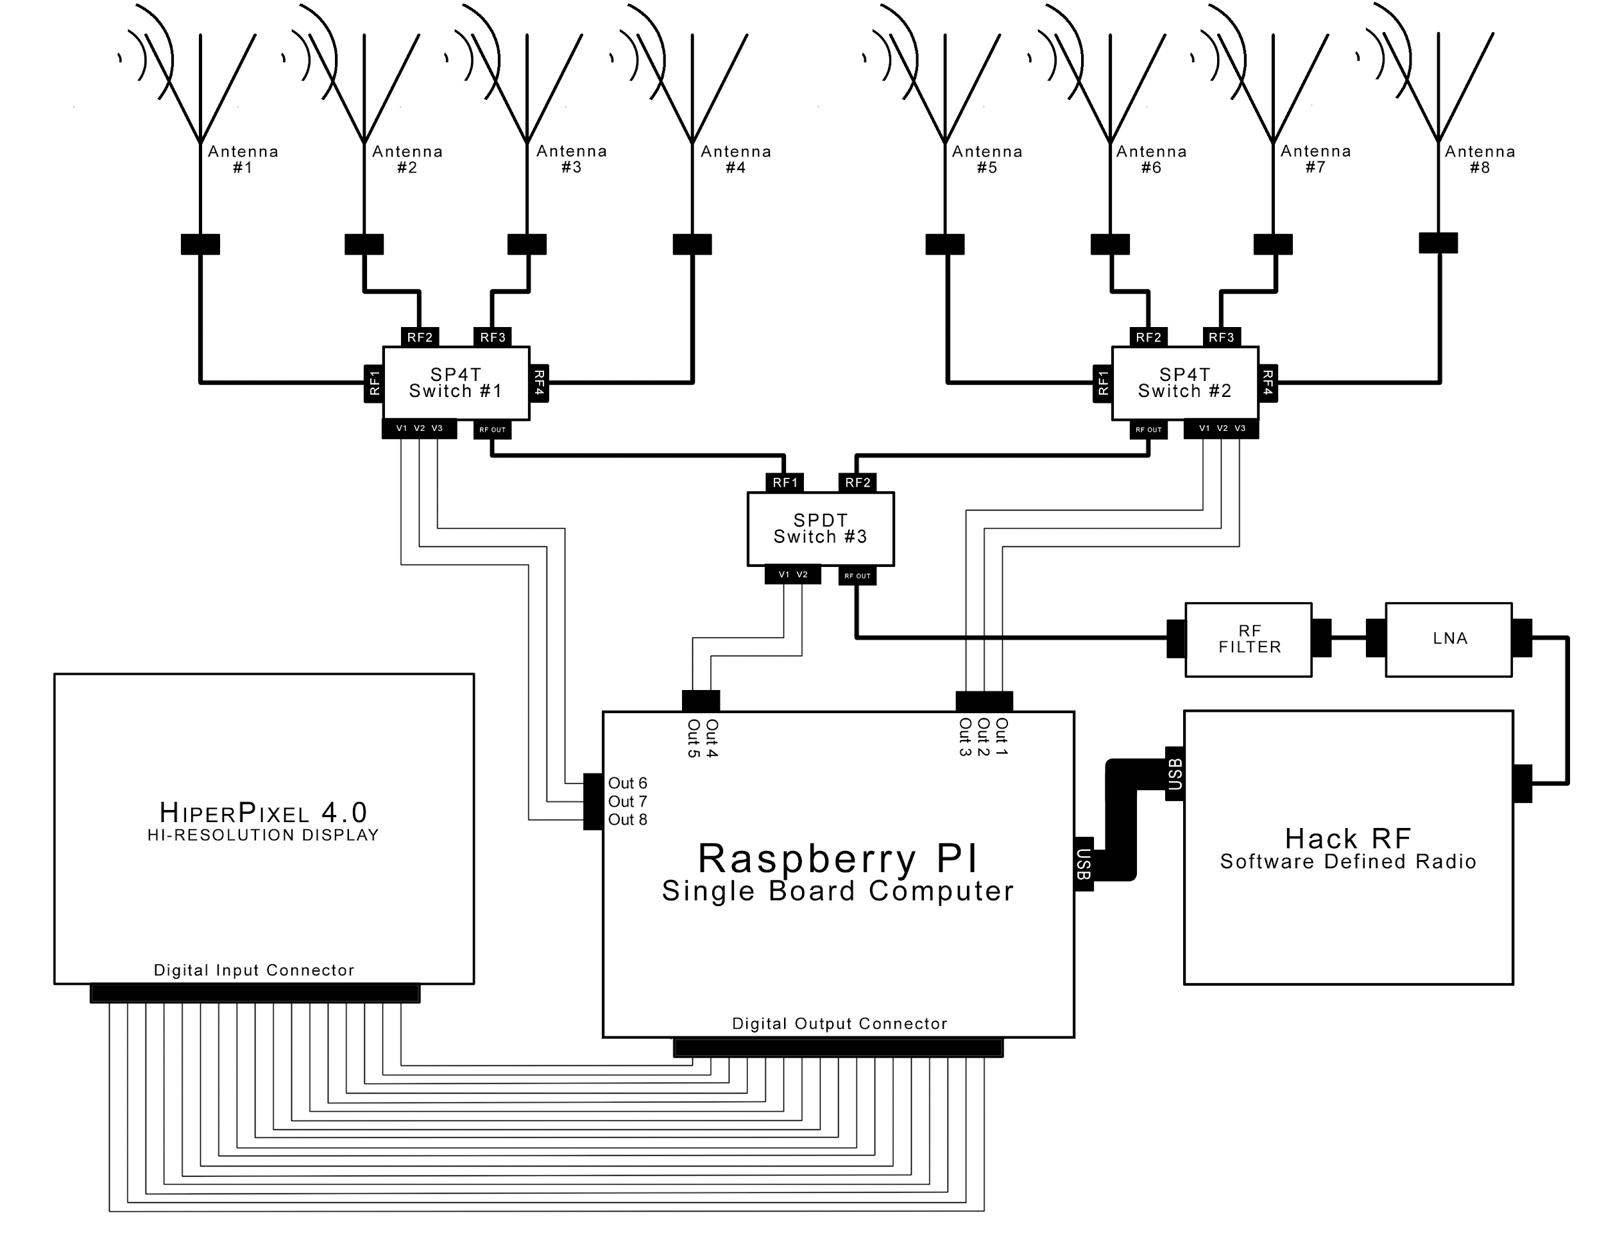

Figure 14- Detailed Design of Internal Communications

# 5 EXTERNAL INTERFACES

This section describes the interfaces between the DoA system and any external systems or subsystems.

## 5.1 Interface Architecture

The primary external system that the DoA system will interact with will be the signal generator. The DoA antenna must be able to detect the generated 5.8GHz signal from the signal generator.

## 5.2 Interface Detailed Design

See diagrams in Human-Machine Interfaces Input and Output.

# 6 SYSTEM INTEGRITY CONTROLS

The system is created for an IEEE competition and will be available to students and staff of Embry-Riddle Aeronautical University. Hence there is no sensitive information to the software of hardware of the system.